Report

Project Name:SUDOKU

Names: Animesh Baranawal, Rawal Khirodkar

Objectives:To create an user interface for playing a sudoku game and a sudoku solver to help solve grids which have a
possible solution

Working:

Basic two parts of project: A]Sudoku game interface
B]Sudoku solver

A]Sudoku game interface:

Aim: To create a user interface which allows user to play a game of Sudoku. The interface shows the number of moves completed by the user and has some other features like saving the game, loading previously saved game, using hints in the game(number of allowed hints = 3) and showing the score of the user which depends on the number of moves of user and number of hints left.

Classes used: griddata - has char data type and int data type as its fields.
The char data type defines whether the square is fixed or variable.
The int data type defines the number filled in the square.

Main Program:
Before the initCanvas starts, input is taken from files called “l1” and “soldata_l1”. Three two dimensional arrays of type griddata are created named newdata, userdata, and soldata.

Functions used: The main function used is Sudoku which creates the total grid by taking input from a file named l1. This file contains the char data type and int data type of each square besides the containing the data showing the level and the highest score achieved in the level. The initial level of the user is l1. Level is increased if user completes the game. There are 3 levels.

The main function Sudoku then can call many sub functions:

1.clickfunction: This function allows the user to fill the number in a square provided the char data type of the square defines it to be variable. When clicked such a square, a number grid appears on the lower side of screen( clickfunction calls another sub-function named number grid). The click of the user is always backtracked via getClick(). If the user clicks on any number in the grid , the number is filled in the square else the square becomes empty.

This function also keeps track of the number of moves completed by the user.

2.complgame: This function checks whether the grid filled matches the solution of the sudoku by matching it with the data which is taken from a file containing the solution of the respective sudoku level. Also, this function calculates the score of the user and overwrites it if the score is greater than the previous highest score.

Also, this function displays a region named next level, which allows the user to move in the next level.

3.The initCanvas has many regions- SAVE GAME, LOAD PREVIOUS GAME, QUIT GAME, HINTS LEFT, NEW GAME...

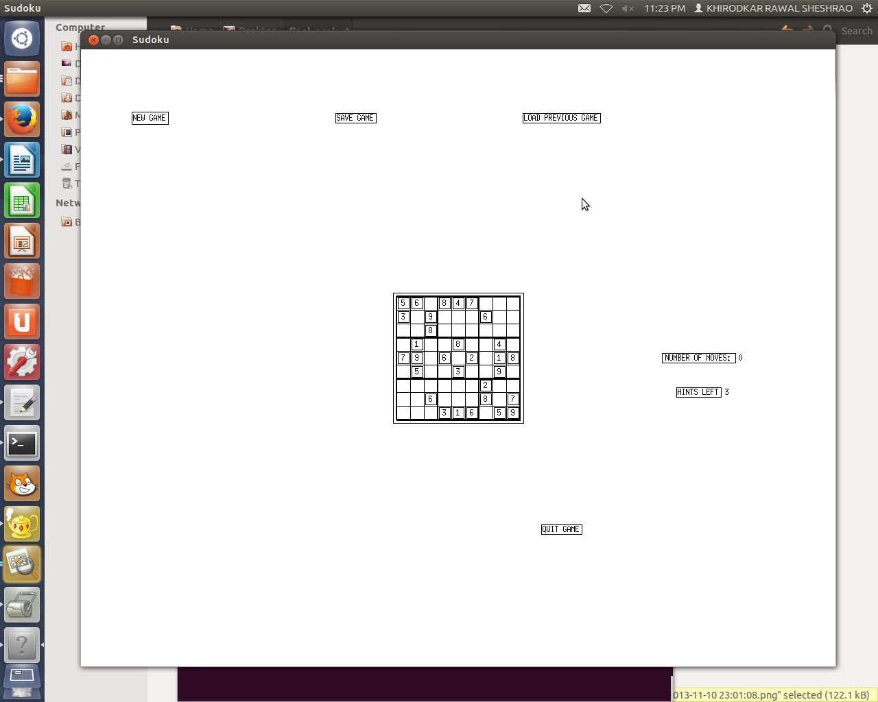

Clicking on the SAVE GAME region: overwrites the grid data into the "userfile" along with the level of sudoku and the number of moves completed by the user.

Clicking on the LOAD PREVIOUS GAME: takes input from the "userfile" and implements it on the grid. This region uses a function called filldata which fills the grid according to the input taken from “userfile”.

Clicking on the QUIT GAME: works by breaking from the while loop(the getClick function is used in a while loop... so the initCanvas always waits for a click and will not quit unless it breaks from the loop).

Clicking on HINTS LEFT region: clicking on this region allows the user to show the number hidden in an empty square in the grid. This works by making the int data type of that empty square equals the int data type of respective square stored in soldata.

Clicking on NEW GAME region: clicking on this region calls sub-sub function filldata. This again takes input from the file containing data of the unfilled grid (of the same level). filldata then fills the grid accordingly. The grid thus seems to be refreshed.

There is another region in the initCanvas called NUMBER OF MOVES.... The number of moves is backtracked via clickfunction.

4.The user interface also allows the user to see whether the number filled by him is correct or not. Every time the user fills an empty square, the validity of the number is checked via the sub-function clickfunction. If the number filled is incorrect(according to the constraints of Sudoku), the respective square blinks (the blinking period in direct proportion to the number of conflicts).

BASIC DISADVANTAGES:
1. Have to wait for displaying the grid.
2. Double clicking is recommended for any step.

B]Sudoku solver:

Strategy: Basically probable numbers possible for an empty box are filled one by one. If a conflict is found, the next probable number is filled. This is continued until no conflicts are found for the particular box. This step is iterated for all the empty squares.

This solves the give Sudoku Grid. The code uses the input in form of integers where empty boxes are
denoted by "0". For example,

INPUT

3 9 0 0 0 2 0 0 6
0 5 0 0 8 6 0 0 0
2 0 0 0 0 0 0 0 3
0 3 0 7 0 0 0 0 0
0 0 1 0 6 0 8 0 0
0 0 0 0 0 1 0 9 0
4 0 0 0 0 0 0 0 7
0 0 0 4 3 0 0 5 0
8 0 0 6 0 0 0 3 2

This sudoku board is then stored in a two dimensional array of data type int using a input function.

a)Class used: EMPTYCELL
Each empty cell is recognized and it is stored as a object of this class via the function emptyfill.

The attributes of the object of this class are: Row number,Column number, Array of probable numbers which can be filled into that empty cell for the given sudoku grid, Size of this probable array,
A boolean variable "single" which is true if the number of probable candidates for this empty cell is just one.

b) Functions used:

1) input: Takes input and stores it in 2D array .

2) check: Checks for conflicts for value to be filled in an empty cell .

3) emptyfill: Analyses the grid for empty cells and fills the address(row,column) of the empty cells in an array of emptycell class accordingly.

4) candidate: This function analyses the empty cells and the board and finds out the probable candidates(possible values) for an emptycell. It thus also fills the array of probable numbers in the EMPTYCELL class data type.

5)singlet: It checks for the number of probable candidates of an emptycell and if there is just one possible value then it changes the boolean variable "single" associated to it as 'true'.

6)update_emptycell (Second most imp function): If corresponding to any emptycell the number of probable candidate is one then it fills that value in that emptycell updating the sudoku 2D array and also updating the array of empty cells removing the filled one from it. Simultaneously, it also updates the new probable candidates for the new array of emptycell according to new grid. A recursive call has been implemented. The recursion is ended only if all the empty cells have their respective probable candidates more than 1.

(Note: The update function is enough for solving an easy Sudoku grid)

7) solver (Most imp function) : It uses hit and trial method on the empty cells filling it with probable values and checking for conflicts.

OUTPUT (Solved grid)

3 9 4 1 7 2 5 8 6
1 5 7 3 8 6 2 4 9
2 8 6 9 4 5 7 1 3
5 3 8 7 9 4 6 2 1
9 4 1 2 6 3 8 7 5
7 6 2 8 5 1 3 9 4
4 1 3 5 2 8 9 6 7
6 2 9 4 3 7 1 5 8
8 7 5 6 1 9 4 3 2

The mechanism used for checking conflicts is same as done while playing sudoku manually. It checks for conflicts horizontally, vertically and also in the 3*3 square of which it is a part of.

NOTE: Solver can not work on a grid that has too many unfilled empty squares or in other words has more than one solution.

c)Algorithm:

The basic algorithm for solving sudoku isimplemented in the solve function.
Every empty cell has a int data type element associated which keeps count of the probable numbers used.
For the an empty cell, the first number from its probable array is checked for conflicts and element of that empty cell is increased by1. If conflict is found, the second number is checked and so on. If conflicts are found regularly, this is continued until element exceeds the number of probable candidates for the array. Once exceeded the number in the previous cell is now changed making the element of the current empty cell =0. This is called “BACKTRACKING”.

In case no conflicts are found, the same process is used for the next empty cell.

The basic steps of the process:

1.Input taken from the user graphically using function of the previous game interface.

2.This data is stored in a two dimensional array of int data type.Data regarding empty cells is created using the function fillempty.

3.update_emptycell is executed.

4.solver function is called only when the the number of empty cells is greater than zero. The solver function also implements sanity check.

5.The final grid is then again converted to graphical format using the functions of game interface only if the sudoku grid is valid(i.e. Solver gets a solution for the grid

A sample valid grid taken from internet along with its solution to its right side is shown on screen

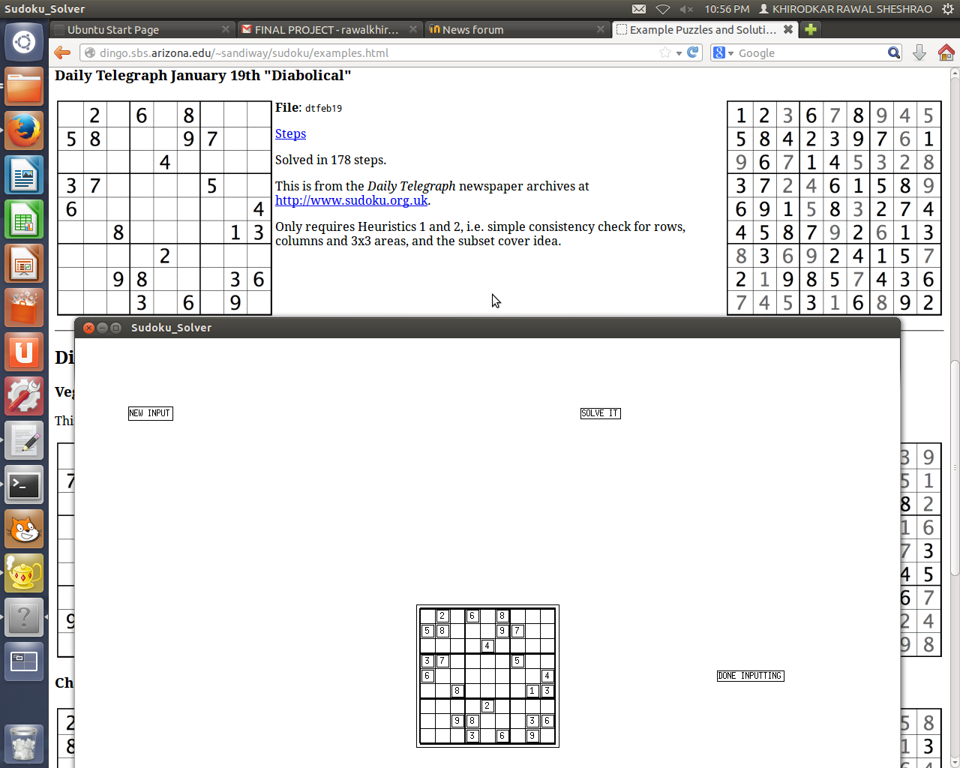
The grid is copied in to canvas and is ordered to be solve

after solving it

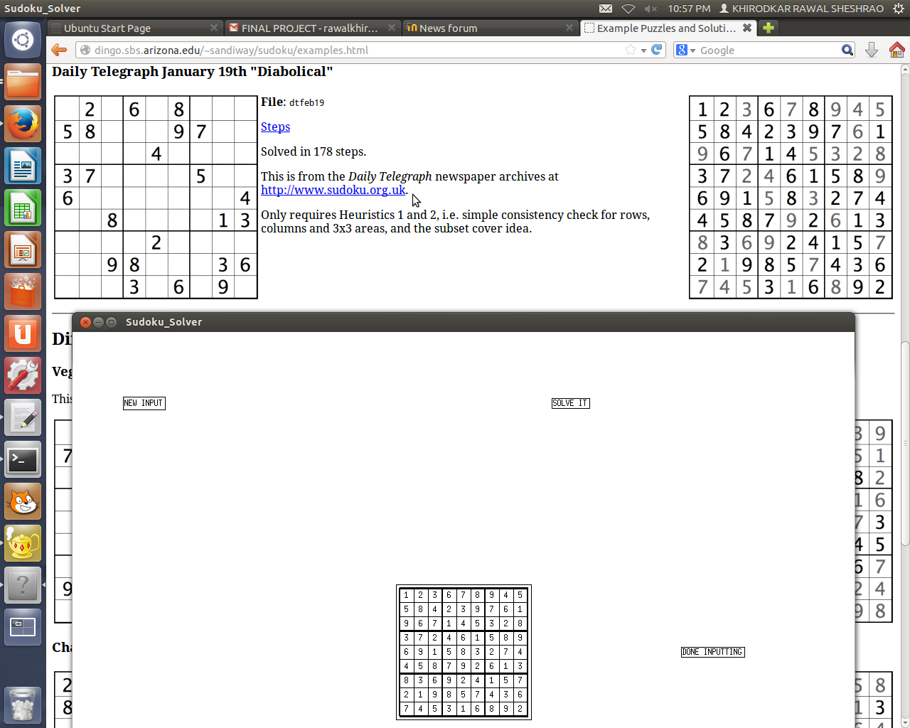

And it matches!!!! :)

For invalid input we have put and sanity check...for example..

